**A**

**Project Report**

**On**

***Image Gallery***

**Submitted by**

***Rishabdev Panchal - 2205103140012***

***Priyanshi Patel - 2205103120030***

***Harshsavardhini - 2205103140018***

**as**

**Partial fulfilment of Semester IV**

**of Bachelors of Computer Applications**

**Bachelor of Science in Information Technology**

**for A.Y. 2023-2024**

**Under the Guidance of**

**Internal Guide Name: Prof. Ashish**

**Submitted To**

**Parul Institute of Computer Application,**

**Faculty of IT & Computer Science**

**Parul University**



**Acknowledgement**

*The success and* *final outcome of this project required a lot of guidance and assistance from many people, and we are extremely privileged to have got this all along the completion of our project. All that we have done is only due to such supervision and assistance and we would not forget to thank them.*

*We respect and thank Dr. Priya Swaminarayan, Dean, FITCS for providing us an opportunity to do the project work in BCA and giving us all support and guidance, which made us complete the project duly. We are extremely thankful to Mam for providing her support and guidance, although she had a busy schedule managing the academic affairs.*

*We would not forget to remember Prof. Hina Chokshi, HOD, BCA department for her encouragement and more over for her timely support and guidance till the completion of our project work.*

*We owe our deep gratitude to our project guide Prof. Ashish, who took keen interest in our project work and guided us all along, till the completion of our project work by providing all the necessary information for developing a good system.*

*We are thankful to and fortunate enough to get constant encouragement, support and guidance from our Parents, all Teaching staff of the BCA Department which helped us in successfully completing our project work. Also, we would like to extend our sincere esteems to all staff in the laboratory for their timely support.*

***Rishabdev Panchal 2205103140012***

***Priyanshi Patel 2205103120030***

***Harsh Vardhan Singh Gahlot 2205103140005***



**PARUL INSTITUTE OF COMPUTER APPLICATION**

**CERTIFICATE**

This is to certify that ***Rishabdev Panchal, Priyanshi Patel and Harsh Vardhan Singh Gehlot*** the student(s) of Parul Institute of Computer Application, has/have satisfactorily completed the project entitled ***Image Gallery*** as a part of course curriculum in IMCA semester- 4 for the academic year 2023-2024 under guidance of ***_Prof. Ashish.***

Enrolment Number: 2205103140012

Enrolment Number: 2205103120030

Enrolment Number: 2205103140005

|  |  |  |
| --- | --- | --- |
| **Quality of work** | **Grade**  **A / A+ /B /B+** | **Sign of Internal guide** |
| **Poor / Average / Good /Excellent** |  |  |

Date of submission:

HOD, Principal,

Dr. Hina Chokshi Dr. Priya Swaminarayan’s

| **Content** **Page No.** |
| --- |
| 1. Introduction to Feedback Detection 1,2 |
| 1. System Requirement Specification 3 |
| * 1. Introduction to SRS 3 |
| * 1. Hardware Requirement 3 |
| * 1. Software Requirement 3 |
| * 1. System Users 4 |
| * 1. Description of User Role 4 |
| * 1. System Modules 4 |
| * 1. Description of Modules 5 |
| * 1. Timeline Chart 5 |
| 1. System Flow Diagram 6 |
| 1. Data Flow Diagram (All Levels of DFD’s) 7,8,9 |
| 1. Use Case Diagram 10 |
| 1. Data Dictionary 15,16,17 |
| 1. Screenshots of Development Phase -1 16 |
| 1. Screenshots of Development Phase -2 17 |
| 1. Screenshots of Development Phase -3 18 |
| 1. Conclusion 22 |
| 1. Future Enhancement 23 |
| 1. References 24 |

**INDEX**

**ABSTRACT**

* Developed a Java-based application for managing digital image collections efficiently.
* Prioritize intuitive interface design for easy navigation and image management.
* Enable secure user registration and personalized access to image galleries.
* Support image uploading, categorization, tagging, and operations like viewing and deletion.
* Employ MySQL database management for robust data storage and retrieval.
* Implement secure authentication mechanisms to protect user accounts and data integrity.
* Employ password hashing and encryption techniques to secure user credentials.
* Design architecture to accommodate potential scalability requirements for managing large image collections efficiently.
* Optimize performance for responsive and reliable image processing and retrieval.
* Explore integration with cloud storage services for backup and synchronization.
* Investigate advanced image recognition and categorization algorithms for automated tagging.
* Provide comprehensive documentation covering installation, usage, and troubleshooting.
* Offer ongoing support and updates to address user feedback and improve the application.

**Chapter 1**

**Introduction to Project System**

"The Image Gallery project is a Java-based application tailored to simplify the management of digital image collections. With a focus on user-friendly functionality and robust security, the application empowers users to effortlessly upload, categorize, and interact with their images. Leveraging Java's versatility and MySQL's reliability, it offers secure user registration, intuitive interface design, and seamless image handling capabilities. By revolutionizing the way users organize and access their images, the project aims to redefine the user experience in digital image management, serving as the ultimate tool for individuals to preserve memories, showcase portfolios, and curate visual inspirations."

**Chapter 2**

**System Requirement Specification**

**2.1 Introduction to SRS**

**2.1.1 What is SRS?**

A software requirements specification (SRS) is a description of a software system to be developed. It lays out functional and nonfunctional requirements and may include a set of use cases that describe user interactions that the software must provide.

**2.1.2 Need of SRS**

In order to fully understand one’s project, it is very important that they come up with a SRS listing out their requirements, how are they going to meet it and how will they complete the project. It helps the team to save upon their time as they are able to comprehend how are going to go about the project. Doing this also enables the team to find out about the limitations and risks early on.

**2.2 Hardware Requirement**

|  |  |
| --- | --- |
| **Hardware Component** | **Specification** |
| Processor | Pentium 2 266 MHz or above |
| RAM | 128 MB or above |
| Hard Disk | 124 MB for JRE, 2 MB for JAVA  Update |
| Device | Mouse and Keyboard |

**2.3 Software Requirement**

|  |  |
| --- | --- |
| **Name of component** | **Specification** |
| Operating System | WindowsXP or above/ OS X 10.8.3 and above |
| Software Development Kit | IntelliJ IDEA or any code editor |
| Programming language | JAVA |
| Database | MySQL |

**2.4 System Users & Modules**

2.4.1 Customer/User

2.4.2 System Administrator

**2.5 Description of Users & Modules**

**2.5.1 Customer/User**

The primary user of a Image Gallery is the one who is gonna interacts with the platform to explore usage of the system.

* + 1. **System Administrator**

As a system administrator for a food ordering website, main responsibilities include managing servers, databases, and security measures, ensuring smooth operation, scalability, and data protection.

**2.6 System Features**

2.6.1 User Authentication and Registration

2.6.2 Stores the Image

2.6.3 View the Image

2.6.4 Delete the Image

**2.7 Description of Features**

**2.7.1 User Authentication and Registration**

Allows users to create accounts, log in, and manage their profiles.

**2.7.2 Stores the Image**

Enables the user to upload their image with details and descriptions.

**2.7.3 View the Image**

Allows users to view uploaded content.

**2.7.4 Delete the Image**

Allows users to view uploaded content.

**2.8 Timeline Chart**

|  |  |  |  |  |  |  |  |
| --- | --- | --- | --- | --- | --- | --- | --- |
| **Development phase** | ***75 Days*** | | | | | | **Duration**  **N**  **(days)** |
| 0to10 days | 11to20  days | 21to30 days | 31to40 days | 41to50 days | 51to75  days |
| **Requirement**  **Gathering** |  |  |  |  |  |  | 07 |
| **Analysis** |  |  |  |  |  |  | 09 |
| **Design** |  |  |  |  |  |  | 10 |
| **Development Phase 1** |  |  |  |  |  |  | 13 |
| **Development Phase 2** |  |  |  |  |  |  | 13 |
| **Development Phase 3** |  |  |  |  |  |  | 13 |
| **Documentation** |  |  |  |  |  |  | 10 |
| **Total time**  **(Days)** |  | | | | | | **75** |

2.8Timeline chart of Image Gallery

**Chapter 3**

**System Flow Diagram**

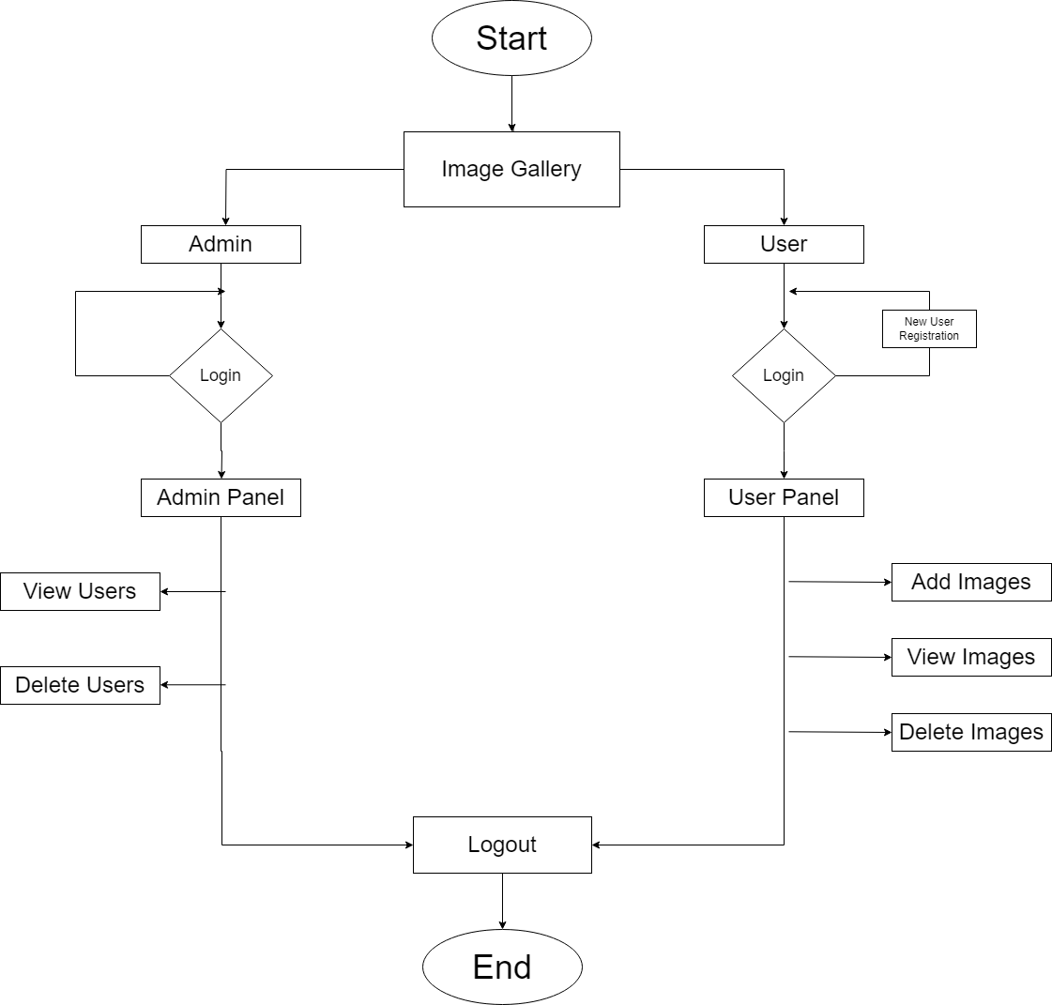

Figure 3 System Flow Diagram of Image Gallery

**Chapter 4**

**Data Flow Diagram**

**Data Flow Diagram of Image Gallery (level-0)**

Figure 4.1 Data Flow Diagram of Image Gallery (level 0)

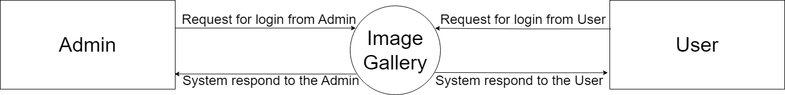

**Data Flow Diagram of Image Gallery (level-1)**

Figure 4.2 Data Flow Diagram of Image Gallery (level 1)

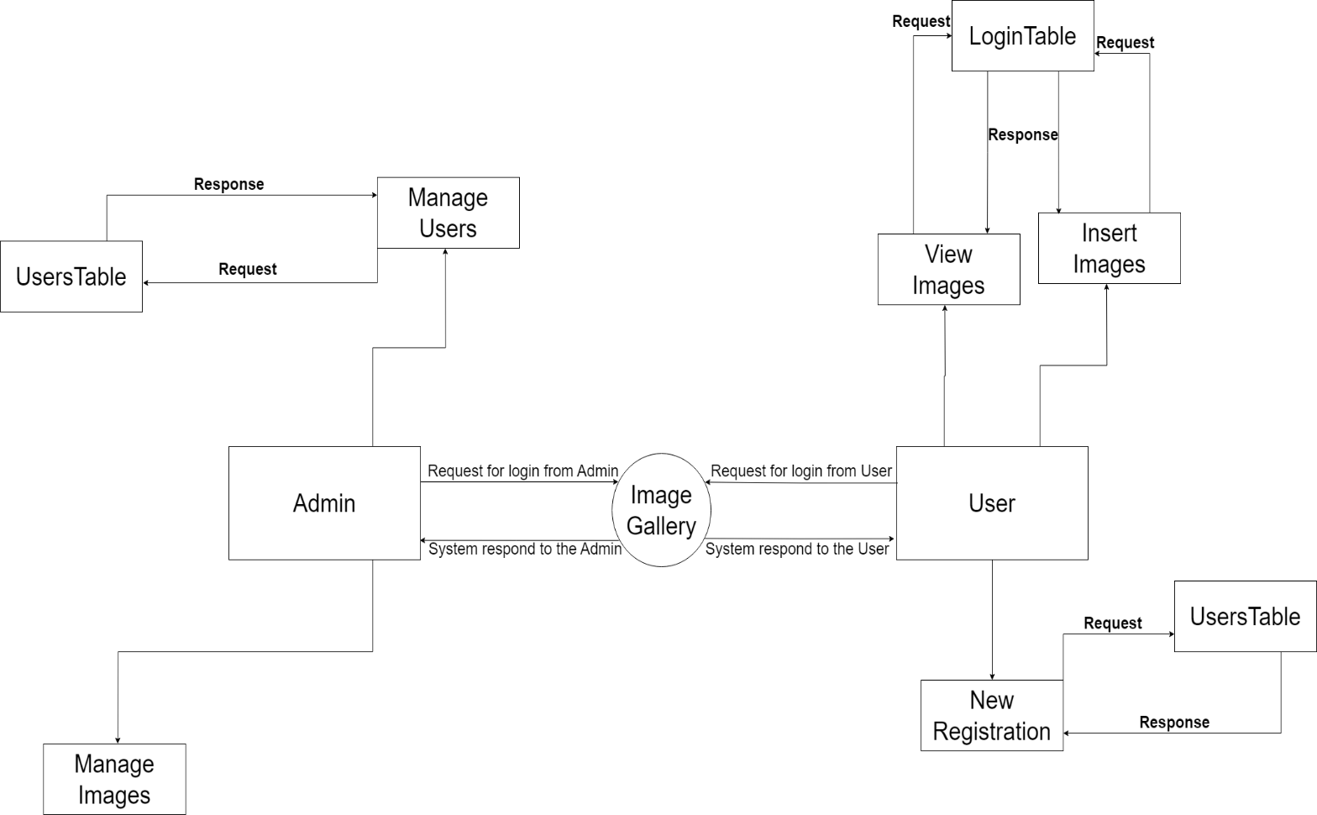

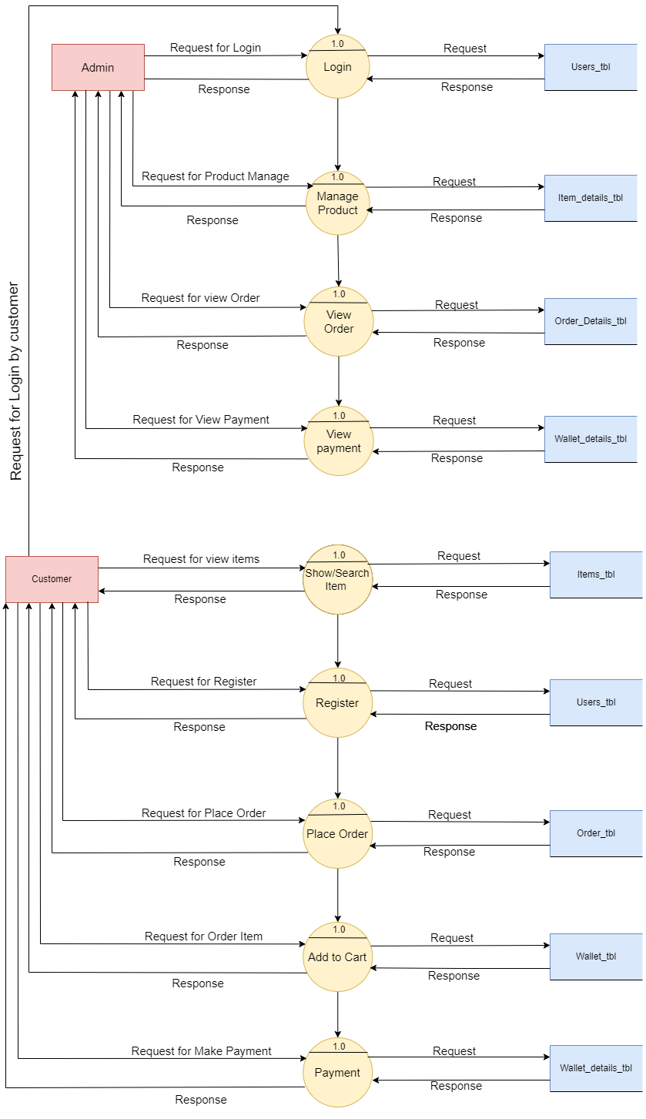**Data Flow Diagram of Image Gallery (level-2)**

Figure 4.3 Data Flow Diagram of Image Gallery (level 2)

**Chapter 5**

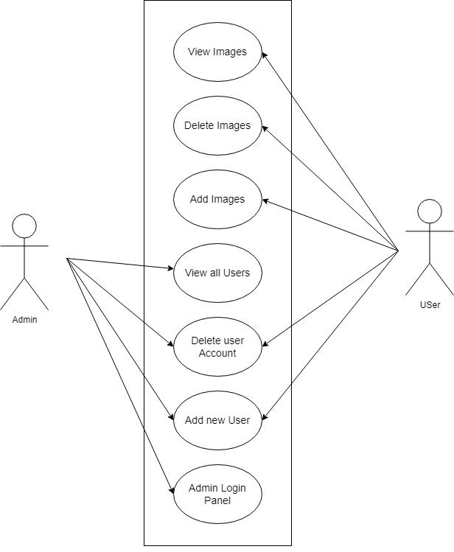**Use Case Diagram**

Figure 5.1 Use Case Diagram of Image Gallery

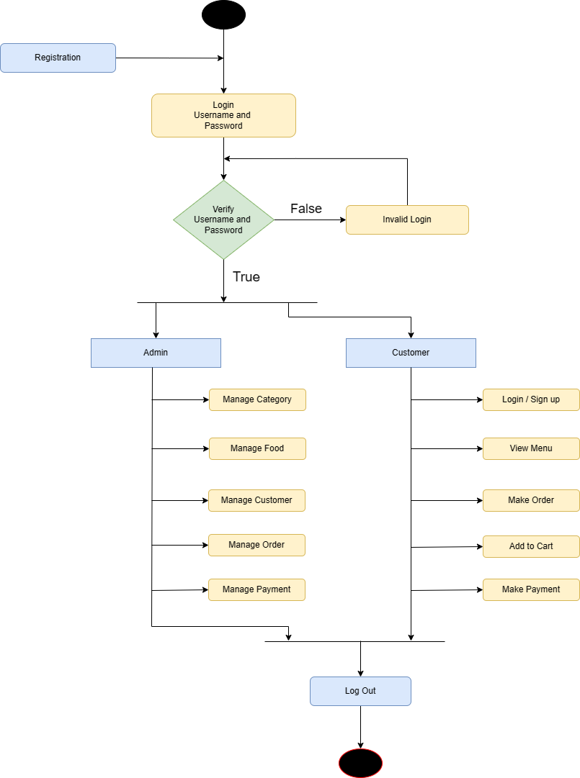**Activity Diagram**

Figure 5.2 Activity Diagram of Image Gallery

**Chapter 6**

**Data Dictionary**

Table Users:

|  |  |  |  |  |  |
| --- | --- | --- | --- | --- | --- |
| Field | Data Type | Null | Key | Default | Extra |
| SrNo | int | NO | PRI | NULL | auto_increment |
| Name | varchar(255) | NO |  | NULL |  |
| Age | int | NO |  | NULL |  |
| DateOfBirth | date | YES |  | NULL |  |
| Gender | varchar(16) | YES |  | NULL |  |
| Username | varchar(255) | NO | UNI | NULL |  |
| Password | varchar(255) | NO |  | NULL |  |

Table Login:

|  |  |  |  |  |  |
| --- | --- | --- | --- | --- | --- |
| Field | Data Type | Null | Key | Default | Extra |
| SrNo | int | NO | PRI | NULL | auto_increment |
| Username | varchar(255) | NO | UNI | NULL |  |
| Password | varchar(255) | NO |  | NULL |  |

**Chapter 7**

**Screenshot of Development Phase 1**

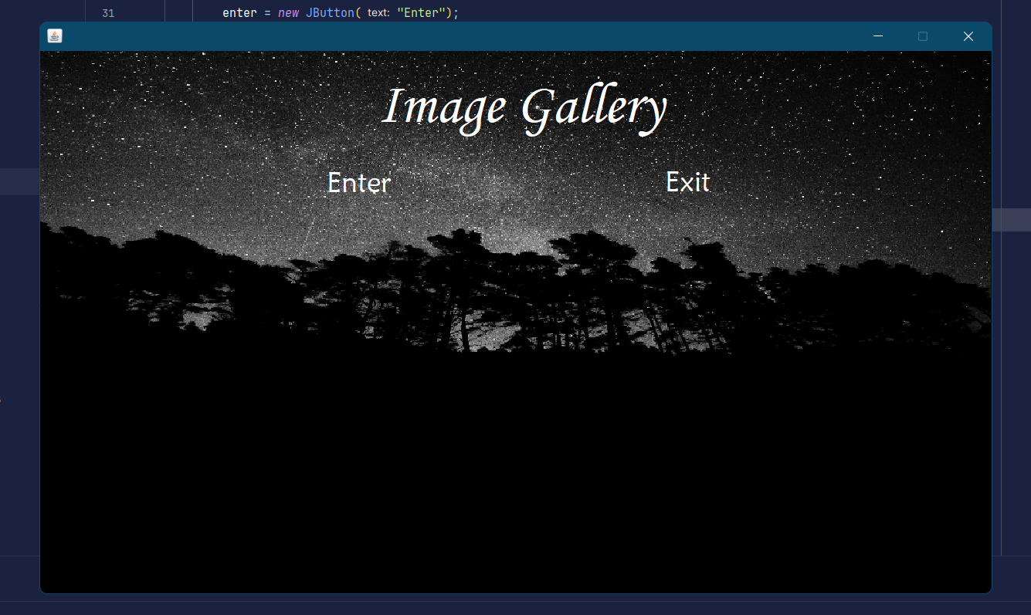**7.1 Image Gallery Front Page design**

Figure 7.1 Home page

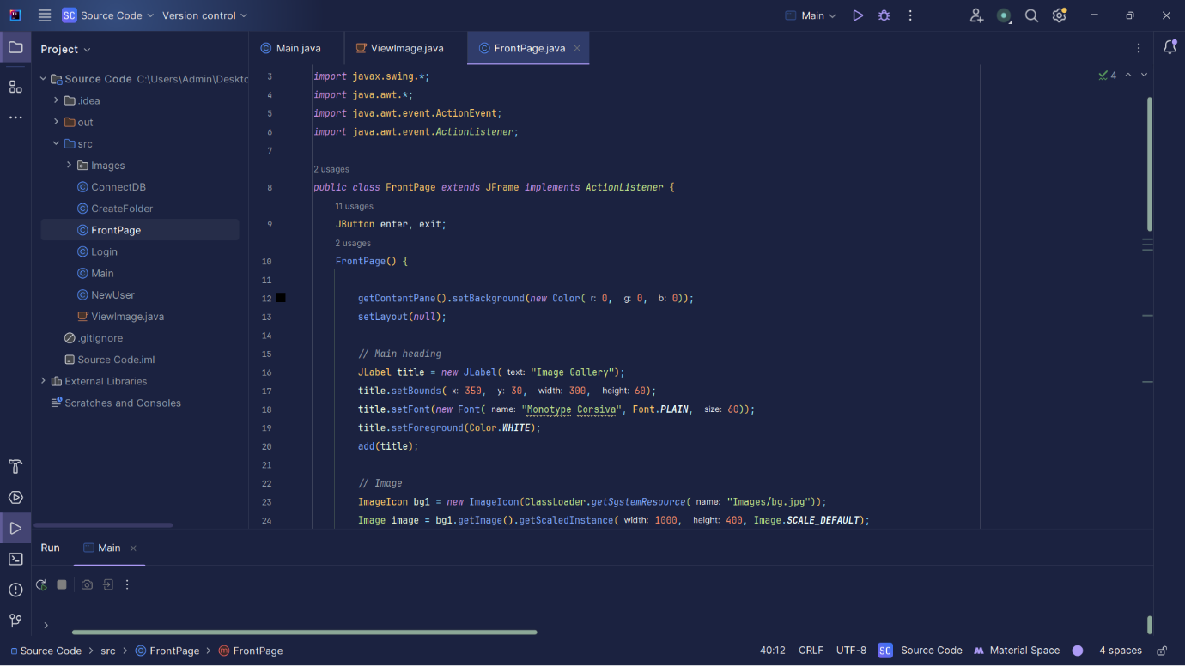**7.2 Code of Image Gallery Front Page**

Figure 7.2 Code of Image Gallery Front page

**Chapter 8**

**Screenshot of Development Phase 2**

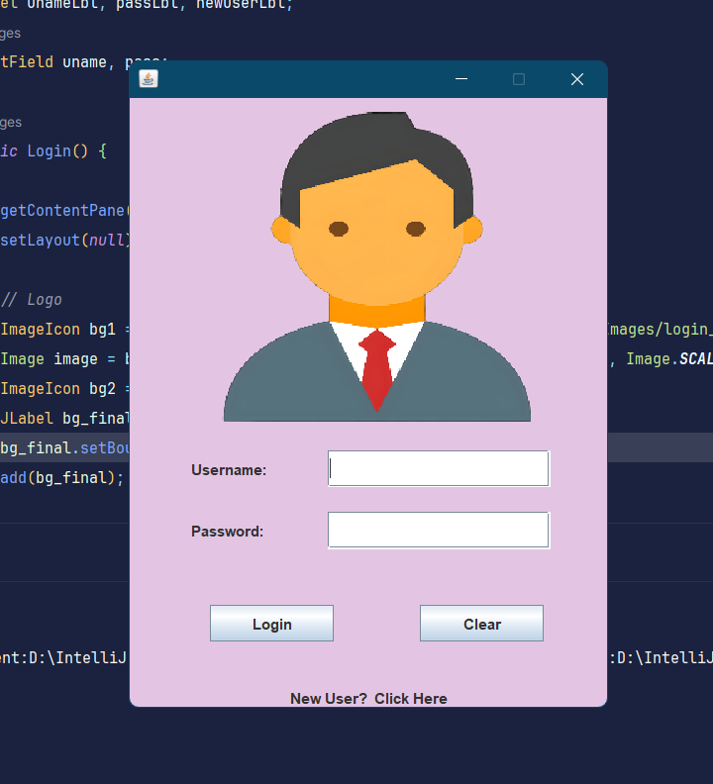**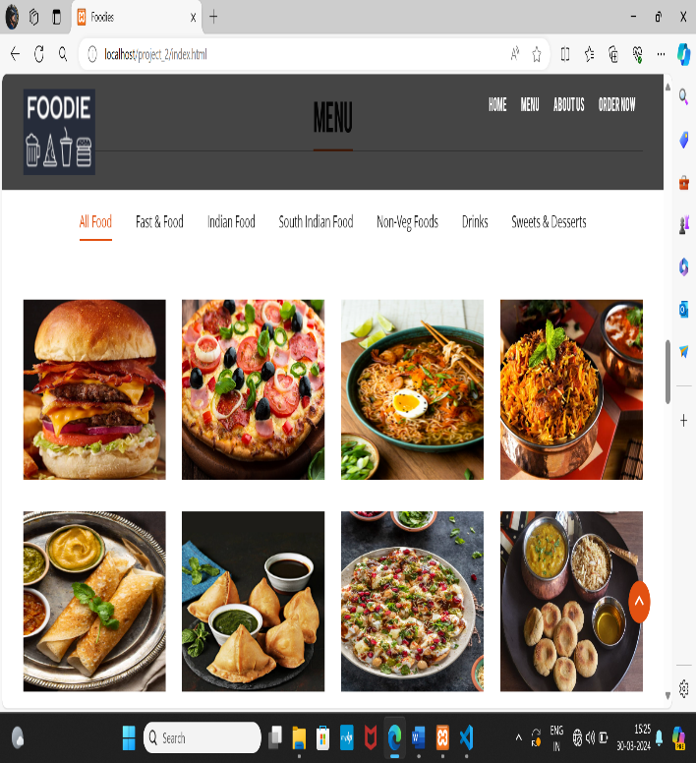8.1 Menu 8 .2 Code of Menu**

Figure 8.1 Statement and Figure 8.2 Code of Statement

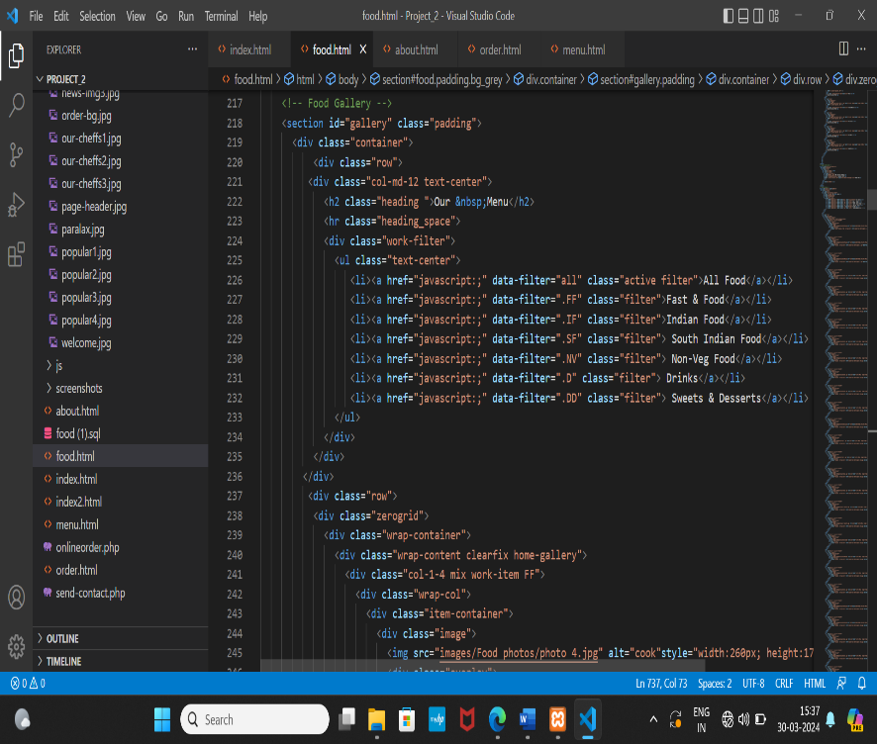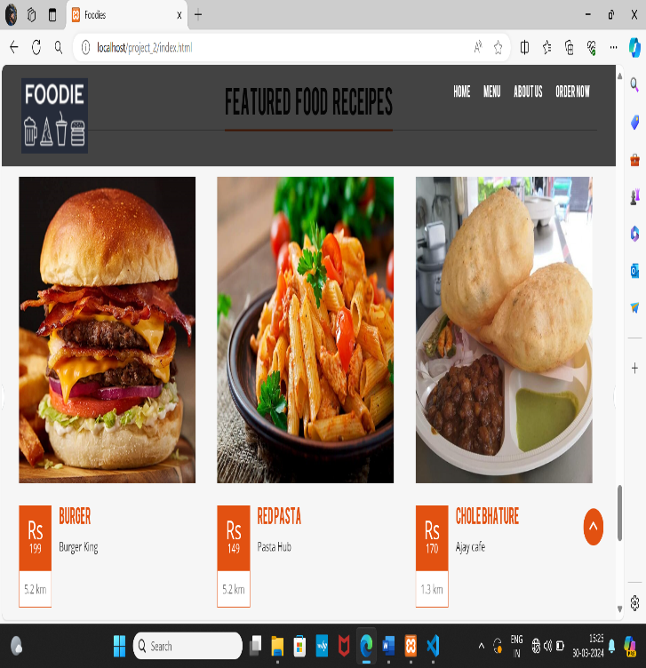**8.3 Featured Food Menu 8.4 Code of Featured Food Menu**

Figure 8.3 Withdraw Figure 8.3 Code of Withdraw

**Chapter 9**

**Screenshot of Development Phase 3**

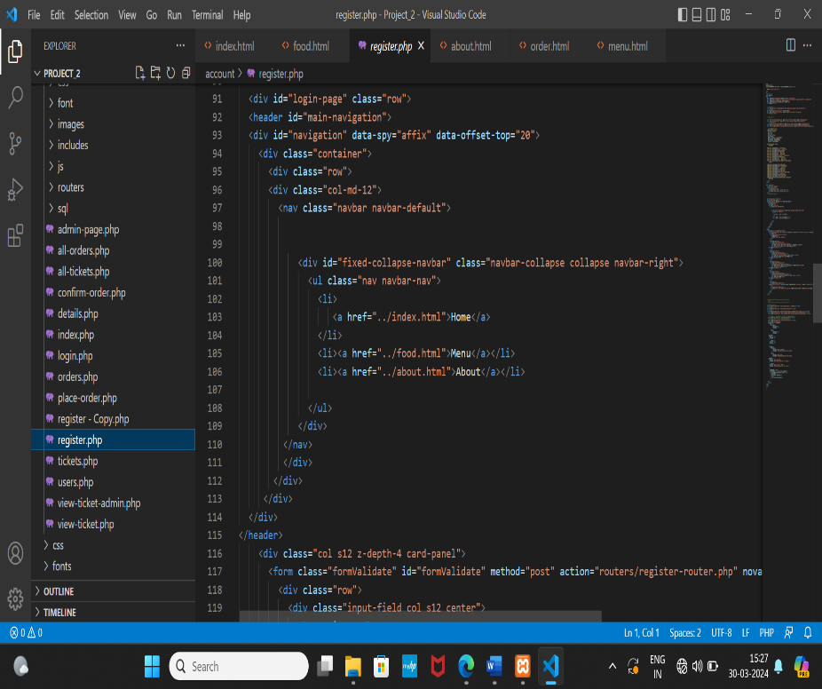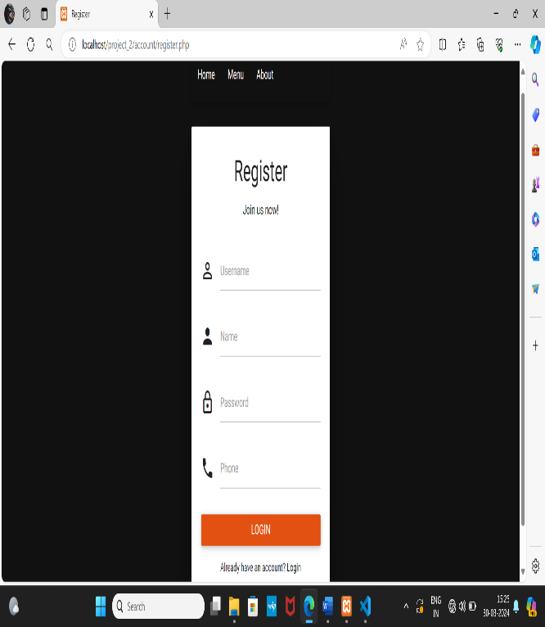 **9.1 Registration 9.2 Code of Deposit**

Figure 9.1 Deposit Figure 9.2 Code of Deposit

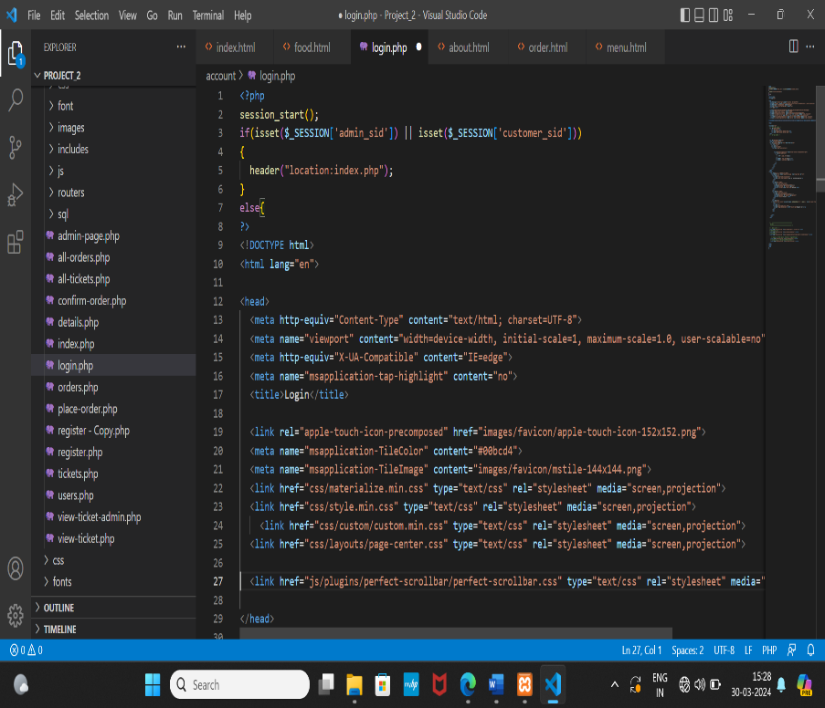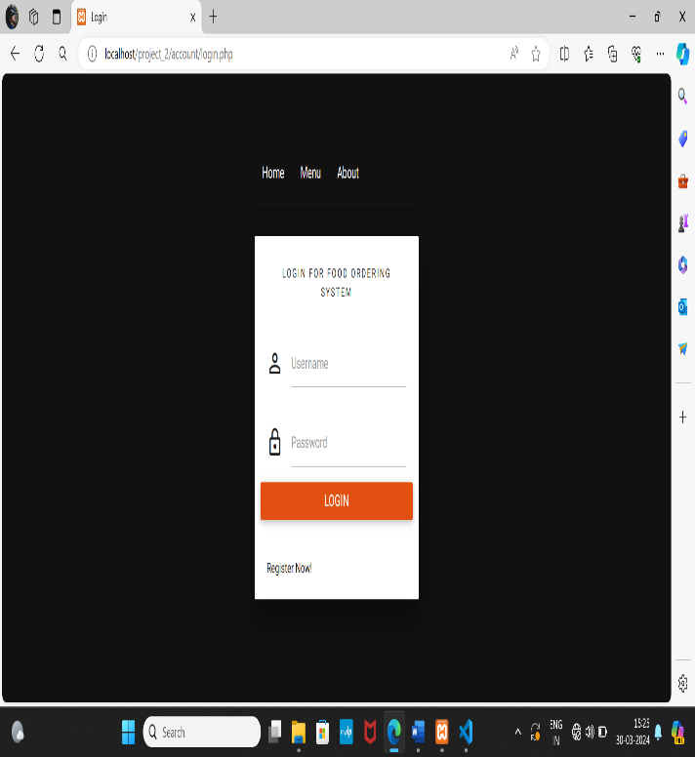**9.3 Change pin 9.4 Code of Change pin**

Figure 9.3 Change pin Figure 9.4 Code of Change pin

**Chapter 10**

**Conclusion**

* The Image Gallery project merges innovation, creativity, and dedication to simplify digital image collection management.
* Through Java and MySQL integration, the application provides an intuitive platform for effortless image organization and access.
* User-centric design principles and robust security measures redefine the digital image management experience.
* The project empowers users to preserve memories, showcase portfolios, and curate visual inspirations with unparalleled ease.
* Continuous improvement ensures the Image Gallery remains the ultimate companion for all image enthusiasts.
* With user-friendly functionality and timeless appeal, the project exemplifies the power of innovation in digital creativity.

**Chapter 11**

**Future Enhancement**

* **Image Sorting:** Allow users to sort their images by date, name, or size for easier **organization an**d access.
* **Image Thumbnails:** Display thumbnails of images in the gallery view to provide users with a quick preview of their images without needing to open each one individually.
* **Bulk Image Upload:** Implement the ability for users to upload multiple images at once, saving them time and effort when adding new images to their gallery.
* **Image Sharing:** Add a feature that allows users to share individual images or entire galleries with others via email or social media.
* **Image Details:** Provide users with the option to view additional details about each image, such as file size, resolution, and metadata.
* **Responsive Design:** Ensure the application's interface is responsive and adapts to different screen sizes, making it accessible and easy to use on both desktop and mobile devices.
* **Keyboard Shortcuts:** Introduce keyboard shortcuts for common actions like navigating between images, deleting images, or opening image details, improving user efficiency.
* **Image Download:** Allow users to download individual images or entire galleries for offline access or backup purposes.
* **Feedback Mechanism:** Implement a feedback mechanism where users can provide suggestions or report issues directly within the application, helping you continuously improve the user experience.

**Chapter 12**

**References**

Website:

1. [www.google.com](http://www.google.com)
2. [chat.openai.com](http://www.google.com)

Book:

1. None

Other Resources:

1. YouTube
2. Chat GPT